<!--This file created 2:29 PM 10/29/97 by Claris Home Page version 2.0-->4.1 Project
Investigating the Folium of Descartes

Computer graphics often requires lots of mathematics, and much mathematics was used in constructing many of the figures in this book. To see where Fig. 4.1.22 came from, use a computer algebra system to solve the equation 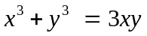 for y in terms of x. Verify that the three expressions you get define three different functions 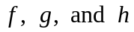 whose graphs are the three branches of the curve that are colored differently in Fig. 4.1.22. Investigate the graphs and domains of definition of these functions to verify that they fit together precisely as pictured in the following figure.

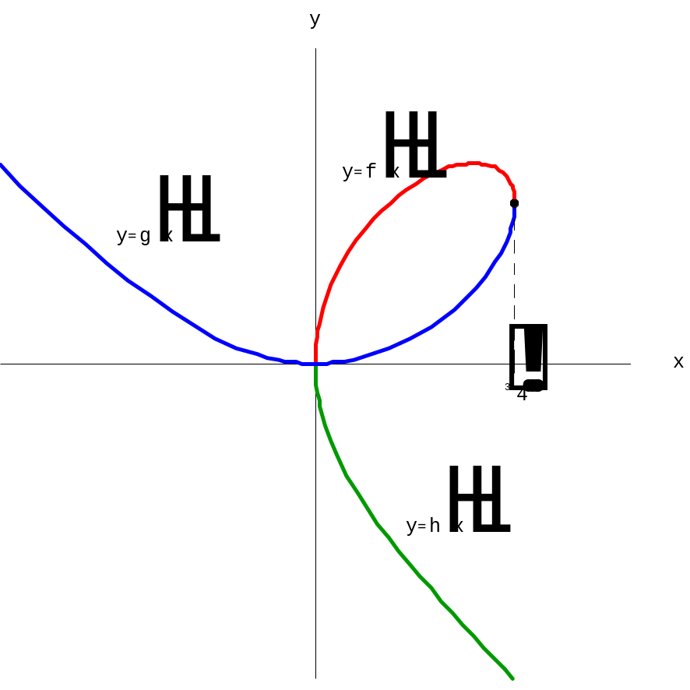

Suggestions Each of the computer algebra system commands

solve(x^3 + y^3 = 3*x*y, y); (Maple)
Solve[x^3 + y^3 == 3x y, y] (Mathematica)
solve('x^3 + y^3 - 3*x*y', 'y') (MATLAB)

produces three solutions that you should be able to simplify to the three functions

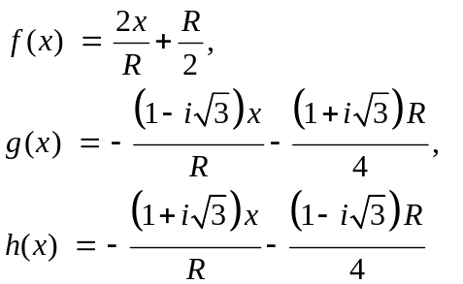

where 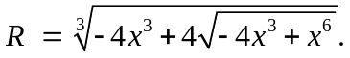

It appears in the figure above that the upper and lower parts of the loop meet at the first-quadrant point where the folium has a vertical tangent line. Can you use the calculations in Example 3 of this section to show that this is the point 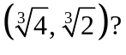

Plot the graphs separately on various trial intervals to convince yourself that — despite the appearance of the imaginary number i the formulas for g and h — these functions are real-valued on the domains

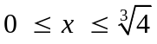 for 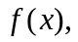
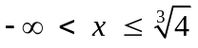 for 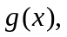 and
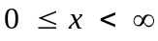 for 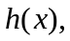

and that their graphs are the red, blue, and green curves (respectively) shown in the figure. We present below some Maple and Mathematica commands you can use.

Using Maple

First, solve for y in terms of x.

eq:=x^3+y^3=3*x*y;
solns:=solve(eq,y):

Then pick out the three solutions of the cubic.

y1:=unapply(solns[1],x):
y2:=unapply(solns[2],x):
y3:=unapply(solns[3],x):

Finally, plot them simultaneously.

branch1:=
plot(fnormal@y1,-2..4^(1/3),color=red,thickness=2):%;
branch2:=
plot(fnormal@y2,0..4^(1/3),color=blue,thickness=2):%;
branch3:=
plot(fnormal@y3,0..4^(1/3),color=green,thickness=2):%;
plots[display](branch1,branch2,branch3,
scaling=constrained);

Using Mathematica

First, solve for y in terms of x.

folium = x^3 + y^3 == 3 x y;
solns = Solve[folium, y];

Then pick out the three solutions of the cubic.

y1 = solns[[1,1,2]];
y2 = solns[[2,1,2]];
y3 = solns[[3,1,2]];

Finally, plot them simultaneously.

branch1 = Plot[y1, {x, 0, 3},
PlotStyle -> RGBColor[1, 0, 0],
PlotRange -> {{-3,3}, {-3,3}}];
branch2 = Plot[y2, {x, 0, 3},
PlotStyle -> RGBColor[0, 0.6, 0],
PlotRange -> {{-3,3}, {-3,3}}];
branch3 = Plot[y3, {x, -2.5, 3},
PlotStyle -> RGBColor[0, 0, 1],
PlotRange -> {{-3,3}, {-3,3}}];
Show[branch1, branch2, branch3]

